KK Lab 1

Friday, February 14, 2025

3:27 PM

Find out using which command you can change the static hostname of your Linux system?

Answer - hostnamectl

sudo hostname vaibhav

1. Effect: Changes the hostname temporarily (until the next reboot).
2. How it works: Modifies the hostname stored in /proc/sys/kernel/hostname.
3. Use case: Useful for testing or temporary hostname changes.
4. Persistence: NOT persistent—it resets after a reboot.

sudo hostnamectl hostname vaibhav

1. Effect: Changes the hostname permanently.
2. How it works:
3. Updates /etc/hostname (which persists after reboots).
4. Communicates with systemd-hostnamed to apply the change.
5. Might also update /etc/hosts in some cases.
6. Use case: Preferred method for changing hostnames on modern Linux systems (CentOS/RHEL7+).
7. Persistence: PERSISTENT—remains after reboot.

If the apropos command does not work because your manual pages are not indexed, what command can you use to manually refresh these?

The mandb command is used If the apropos command does not work because your manual pages are not indexed.

The apropos command in Linux searches manual pages for commands that contain a specified keyword. It's useful when you know what you want to do but can't remember the exact command name.

How to use apropos

Type apropos followed by the keyword you want to search for.

If the output of apropos includes a section number, you can use the man command to view the manual page for that section.

Which section of the manual pages deals with System administration commands?

Section 8 of the manual pages deals with System administration commands.

Use- man man command.

Using the apropos command, find out the configuration file for NFS mounts and save its name in the /home/bob/nfs file.

apropos "NFS mount"

Files and Directories

Saturday, December 21, 2024

9:16 PM

ls - ‘ls’ will display the contents of the current directory. By default, ‘ls’ lists in alphabetical order.

Flags/Options used with ls

a = Used to list files and directories including the hidden ones.

l = known as a long format that displays detailed information about files and directories.

t = Sort files and directories by their last modification time, displaying the most recently modified ones first.

h = Print file sizes in human-readable format (e.g., 1K, 234M, 2G).

Linux organizes the file and directories into a Filesystem Tree.

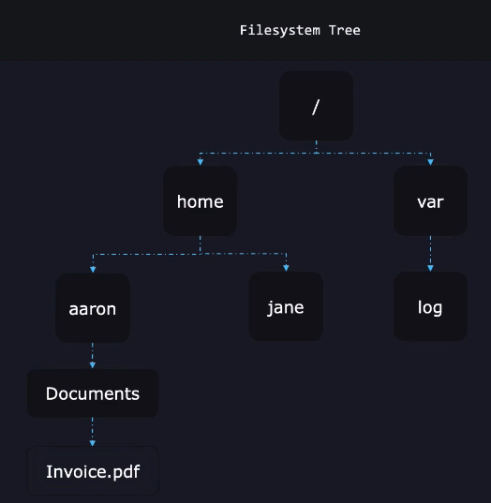

Absolute Path = It starts with the root directory (/).

e.g. /home/aaron/Documents/Invoice.pdf

pwd - This command is used to print the current working directory

Relative Path

Note - Every user starts from their home directory.

cd = change directory

.. = It refers to parent directory of the current directory.

cd / = It will take you directly to the root directory.

cd - = It will take to the previous working directory

cd = cd command without any option will take you to the home directory.

touch - Used to create a file.

mkdir - TO create a new directory.

cp <source> <dest> = TO copy a file located at source to the destination.

It is a good practice to end the directory with '/'. e.g. cp abc.txt /home/aaron/

Copy a Directory

cp -r <source> <destination> = r means recursive, cp -r will copy the directory and it's content to destination.

What if a folder already exists or file already exists at the location where you are choosing the destination?

e.g. cp -r Receipts/ BackupReceipts/

In directory case: If BackupReceipts directory already exists, it will create a directory 'Receipts' under the 'BackupReceipts' directory.

Move

mv <source> <destination>

To rename a file, you can also use this

e.g. mv Receipt.pdf OldReceipt.pdf

To rename a directory

e.g. mv Receipts/ OldReceipts/

There is no need of using '-r' options with mv command.

Remove

rm <filepath>

rm -r <directory path>

Hard Links

Saturday, December 21, 2024

9:50 PM

Inode - Filesystems like xfs, ext4 etc. keeps track of their data with the help of inodes. Each file has an inode number. So, when your search for a file, it goes to inode.

An **inode** (short for **index node**) is a data structure used by Linux and UNIX-like file systems (e.g., ext4) to store metadata about a file or directory.

An inode contains:

* + File type (regular file, directory, symbolic link, etc.)
  + File size
  + Permissions (read, write, execute)
  + Ownership (UID, GID)
  + Timestamps (e.g., created, modified, accessed)
  + Number of hard links
  + **Pointers to the data blocks** where the file's actual contents are stored

**Note:** Inodes do not store the file name; file names are stored in directory entries that link to inodes.

**How Inodes Work When Running cat family_dog.jpg**

When you execute the command cat family_dog.jpg, here's what happens step-by-step:

* + **Resolving the File Name to an Inode:**
    - **The file system first looks up the file name family_dog.jpg in the directory where it's located.**
    - **The directory is essentially a mapping of file names to their inode numbers.**
    - **Once the file name is found, the inode number associated with family_dog.jpg is retrieved.**
  + **Accessing the Inode:**
    - **Using the inode number, the file system locates the inode structure for family_dog.jpg on the disk.**
    - **The inode contains the metadata of the file and pointers to the actual data blocks where the file's contents (binary data of the image) are stored.**
  + **Reading Data Blocks:**
    - **The inode's data block pointers guide the file system to the physical locations on the disk where the binary data of family_dog.jpg is stored.**
    - **The data is read block by block into memory.**
  + **Outputting Data:**
    - **The cat command reads the file data from memory and outputs it to the terminal.**
    - **Since family_dog.jpg is a binary file (an image), the terminal displays unintelligible characters because the binary content isn’t meant for human-readable output.**

**Find the Inode Number of a File:**

ls -i family_dog.jpg

**View File Metadata (Including Inode Info):**

stat family_dog.jpg

**Check Inode Usage for a File System:**

df -i

This shows the number of used and free inodes on each file system.

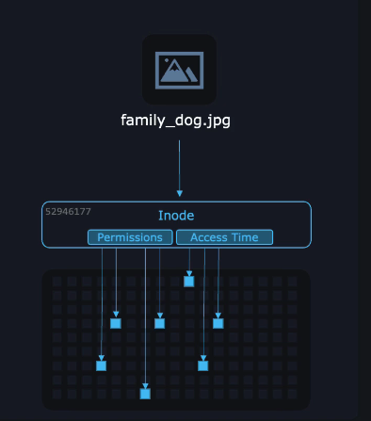

What are the processes run behind when we create and save a file. e.g. echo "Picture of Milo the dog" > Pictures/family_dog.jpg

**1. Command Interpretation**

* + The shell parses the command:
    - echo "Picture of Milo the dog": Outputs the string "Picture of Milo the dog".
    - >: Redirects the output to a file.
    - Pictures/family_dog.jpg: Specifies the file where the output should be saved.

**2. File Redirection (>)**

* + The shell uses the file redirection operator (>) to manage the following:
    - If the file family_dog.jpg **does not exist**:
      * A new file is created in the Pictures directory.
    - If the file **already exists**:
      * Its contents are truncated (emptied) before the new data is written.

**3. System Call: File Creation or Opening**

* + The shell requests the kernel to open or create the file via the **open() system call**

**4. Inode Allocation (if the File is New)**

* + If the file is new:
    - The file system allocates an inode for the file.
    - Metadata (e.g., owner, permissions, timestamps) is initialized and stored in the inode.
  + If the file exists, the inode is retrieved, and the modification timestamp is updated.

**5. Writing Data to the File**

* + The kernel handles writing the string "Picture of Milo the dog" to the file.

**6. Updating Metadata**

* + The inode is updated to reflect changes:
    - File size: Set to the number of bytes written (e.g., 25 bytes for "Picture of Milo the dog\n").
    - Last modification time: Updated to the current time.
  + The file system ensures the changes are stored in memory buffers for performance reasons.

**7. Flushing Data to Disk**

* + The kernel writes the updated inode and file data to disk in two steps:
    - **Metadata update:** Writes inode changes to disk.
    - **Data block write:** Saves the file's contents to physical disk blocks.

**8. File Descriptor Closure**

* + The file descriptor is closed via the **close() system call**

Suppose a file is large, how inodes keeps the track of all the data blocks?

an inode has a limited size (usually 128 or 256 bytes in most file systems like ext4), so it cannot directly store pointers to all data blocks for a large file.

**2. Direct and Indirect Pointers**

To handle this limitation, the inode uses a combination of **direct pointers** and **indirect pointers**:

**Direct Pointers**

* + The inode contains a fixed number of pointers (usually 12) that directly point to data blocks.
  + For small files that fit within these direct pointers, no additional structure is needed.
  + Example: If each block is 4 KB and the inode has 12 direct pointers, it can handle up to **48 KB** of data (12 × 4 KB) directly.

**Indirect Pointers**

For larger files, the inode uses indirect pointers, which add another layer of indirection to point to additional blocks:

* + **Single Indirect Pointer**:
    - **Points to a block that contains pointers to more data blocks.**
    - **Example: If a block can store 1024 pointers (4 bytes each in a 4 KB block), this adds 1024 × 4 KB = 4 MB of additional capacity.**
  + **Double Indirect Pointer**:
    - **Points to a block that contains pointers to other blocks, which in turn contain pointers to data blocks.**
    - **Example: Adds 1024 × 1024 × 4 KB = 4 GB of capacity.**
  + **Triple Indirect Pointer**:
    - **Points to a block that contains pointers to other blocks, which point to yet another set of blocks that contain pointers to data blocks.**
    - **Example: Adds 1024 × 1024 × 1024 × 4 KB = 4 TB of capacity.**

**3. Example for Large Files**

Suppose you have a file that is **6 MB** in size with a block size of 4 KB:

* + The first **48 KB** is handled by the 12 direct pointers.
  + The next **4 MB** is handled by a single indirect pointer.
  + The remaining data (approximately 2 MB) is handled by a double indirect pointer.

**Accessing Data**

When the system accesses a large file, it follows these steps:

* + It checks the inode for direct pointers or indirect pointers.
  + If indirect pointers are involved, the kernel reads the intermediate blocks to locate the actual data blocks.
  + This hierarchical structure ensures efficient storage and retrieval.

HARD LINKS

Each hard linked file is assigned the same Inode value as the original, therefore they reference the same physical file location. Hard links more flexible and remain linked even if the original or linked files are moved throughout the file system.

ls -l command shows all the links with the link column shows number of links.

Links have actual file contents

Removing any link, just reduces the link count, but doesn’t affect other links.

Even if we change the filename of the original file then also the hard links properly work.

We cannot create a hard link for a directory to avoid recursive loops.

The disadvantage of hard links is that it cannot be created for files on different file systems and it cannot be created for special files or directories.

So, If you had an external drive mounted at /mnt/backups, you would not be able to hard link

a file from your SSD e.g. /home/aaron to an external file on /mnt/backups, since that's a different file system.

The advantage of hard links is that your data is not copied so, it helps to save the storage : )

$ ln [original filename] [link name]

In /home/aaron/Pictures/fami1y_dog.jpg /home/jane/Pictures/fami1y_dog.jpg

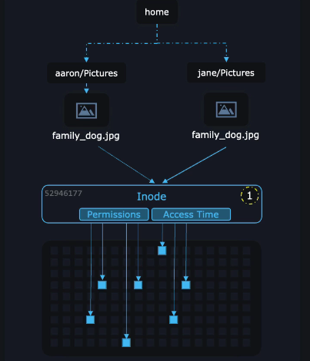

stat Pictures/family_dog.jpg

Output

links: 2

When there are zero links to an inode, the data itself will disappear from the file system.

Technically, the data blocks are not actually erased, but they're just marked as unused so that the system can overwrite them with new data.

Points to Remember while creating a hard link

* + We need right permission, to create a hard link at that destination.
  + when you hard link a file, make sure that all users involved have the required permissions

to access that file. You only need to change permissions on one of the hard links. That's because you're actually changing permissions stored by the inode.

Soft Links

Sunday, December 22, 2024

11:08 AM

A Soft Link is also called a Symbolic Link or symlink.

Soft Links are like 'shortcuts' in Windows.

While Hard Links point to an inode, soft links point to a path instead.

ln -s target_path link_name

Soft Link contains the path for original file and not the contents.

Removing soft link doesn’t affect anything but removing original file, the link becomes “dangling” link which points to nonexistent file.

If you list a soft link using ls -l command, It will display the path at which soft links point to.

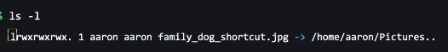

Soft link file has filetype as 'l'.

If you want to link files across the file systems, you can only use symlinks/soft links.

A soft link can link to a directory.

You can create a multiple softlinks.

readlink command

The ‘readlink’ command helps you determine the exact path that a soft links point to.

Types of Symbolic Links :

There are two types of symbolic links : Absolute symbolic links, and Relative symbolic links.

1. Absolute Symlink

An absolute symlink uses the full path to point to its target file or directory.

It is independent of the location of the symlink. Even if the symlink is moved, it can still locate the target file as long as the absolute path remains valid.

ln -s /home/user/Documents/file.txt /tmp/my_symlink

/tmp/my_symlink points to /home/user/Documents/file.txt.

Even if the symlink /tmp/my_symlink is moved to another directory, it will still point to the target file /home/user/Documents/file.txt.

1. Relative symlink

A relative symlink is created using a path relative to the location of the symlink.

ln -s ../Documents/file.txt /home/user/Desktop/my_symlink

What Happens:

../ navigates up one level from /home/user/Desktop to /home/user.

../Documents/file.txt resolves to /home/user/Documents/file.txt.

ln -s ../../shared/resources/manual.pdf /home/user/Desktop/manual_link

**What Happens:**

* ../../ navigates up two levels from /home/user/Desktop to /home.
* ../../shared/resources/manual.pdf resolves to /home/shared/resources/manual.pdf.

How Relative Symlinks Can Break

Relative symlinks are **dependent on the relative position** of the symlink to its target. If this relationship changes (e.g., the symlink or target is moved), the symlink will break.

Scenario 1: Moving the Symlink

If we move /home/user/Desktop/my_symlink to /tmp/:

mv /home/user/Desktop/my_symlink /tmp/

Why It Breaks:

The relative path ../Documents/file.txt now resolves to /tmp/Documents/file.txt, which doesn’t exist.

Scenario 2: Moving the Target

If we move /home/user/Documents/file.txt to /home/user/Archives/:

Why It Breaks:

The symlink /home/user/Desktop/my_symlink still points to ../Documents/file.txt, but that path is now invalid because the target has been moved.

cenario 3: Renaming the Parent Directory

If we rename /home/user/Documents to /home/user/MyDocs:

Why It Breaks:

The symlink /home/user/Desktop/my_symlink still points to ../Documents/file.txt, but the Documents directory no longer exists.

KK Lab 2

Friday, February 14, 2025

4:13 PM

Copy the /home/bob/myfile.txt file to the/home/bob/data/ directory. Make sure to preserve its attributes.

cp -p /home/bob/myfile.txt /home/bob/data/

When copying a file in Linux, an "attribute" refers to a specific characteristic of the file, like its ownership, permissions (read/write/execute), creation date, or modification date, which can be preserved or modified during the copy process using options with the "cp" command, most commonly with the "-p" flag to preserve all attributes.

Difference between cp -a and cp -p?

👉 When to Use What?

Use cp -p when you need to copy only files and want to retain permission, ownership and timestamps.

Use cp -a when you need a full backup or to copy an entire directory exactly as it is, including symbolic links and special files.

Move all contents, excluding the directory itself, from /home/bob/lfcs to /home/bob/new-data/ directory.

mv /home/bob/lfcs/* /home/bob/new-data/

Create a directory named 9 under the /tmp/1/2/3/4/5/6/7/8 directory.

mkdir -p /tmp/1/2/3/4/5/6/7/8/9

Find another way to make ls display the full/exact last modified time for the files in /home/bob directory.( ls -l)

ls --full-time

File Permissions

Sunday, December 22, 2024

3:10 PM

Owner

Owner of a file can change the permissions of that file.

Root user can change the permissions of any file.

Group

The `chgrp` or change group command in Linux is used to change the group ownership of a file or directory.

e.g.

chgrp <group name> <file/directory>

We can only change the group for which the current user is part.

chown

The `chown` command, short for “change owner,” is a powerful tool that allows users to change the owner of files and directories.

chown <username> <file/directory>

But only the root user can change the file/directory owner. So, always use 'sudo chown'.

User and Groups can change simultaneously using following command;

sudo chown <user name>:<group name> abc.txt

-rw-r--r-- 1 user group 46 Apr 14 16:37 NarX.txt

The above command represents these following information:

The first character ‘-‘, which means it’s a file ‘d’, which means it’s a directory.

b = Block File

c = Chracter File

l = Soft Link

- = Regular Files

The next nine characters = (rw-r–r–) show the security

First three, shows the 'owner'.

Next three, shows the 'group'.

Last three, shows the 'others'.

In case of file

r = read

w = write

x = execute

- = No permission

In case of directory

r = can read the content of this directory. For 'ls' command

w = can write( create or delete) files or directory under this directory. For 'mkdir' command

x = can 'cd' into that directory

To access a directory, you need 'r' and 'x' both permissions.

The next column shows the owner of the file.

The next column shows the group owner of the file. (which has special access to these files)

The next column shows the size of the file in bytes.

The next column shows the date and time the file was last modified.

A file user 'r' permission for owner named 'aaron', 'rx-' for a group named 'family' to which

'aaron' belongs.



So, will aaron allow to write or make changes to family_dog.jpg file?

Solution

No.

In linux, permissions are evaluated in a linear fashion from left to right.

So, first check , who's going to open this file.

* + It's Aaron, Aaron is owner. So, Owner permission applied. Aaron can read the file. Write permission denied.
  + It’s Jane. Jane is part of 'Family' group. So, group permission applied. Jane can read and write both to the file.
  + If the user trying to access the file is not the owner and is also not in the family group, the last three permissions would apply, the permissions for other users.

Changing Permissions

The command you use to change the security permissions on files is called “chmod“, which stands for “change mode” because the nine security characters are collectively called the security “mode” of the file.

chmod <permissions> <files/directories>

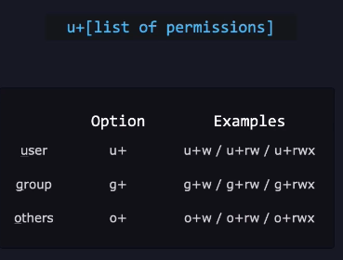

'+’ to say that you are “adding” permission.

chmod o+r xyz.txt

You can also change multiple permissions at once. For example, if you want to take all permissions away from everyone, you would type.

chmod ugo-rwx xyz.txt

'-' to remove the permissons.

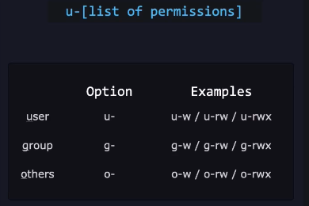

chmod ug+rw,o-x abc.mp4

The code above adds read(r) and write(w) permission to both user(u) and group(g) and revoke execute(x) permission from others(o) for the file abc.mp4.

'=' to exactly apply the permissions.

chmod ug=rx,o+r abc.c

assigns read(r) and execute(x) permission to both user(u) and group(g) and add read permission to others for the file abc.c.

chmod g= family_dog.jpg

This will remove all the group permisson. You can also use

chmod g-rwx family_dog.jpg

chmod ugo= gamily_dog.txt

?

Octal Permissions

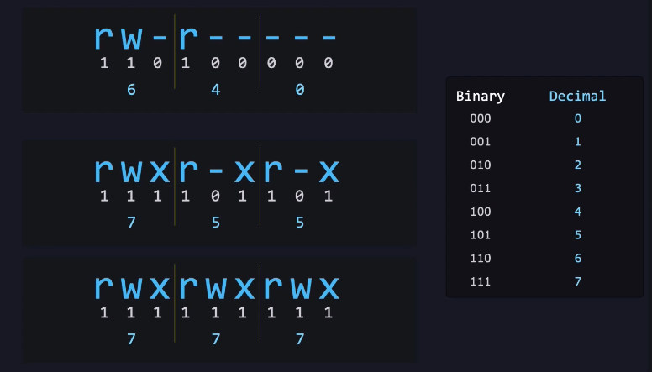

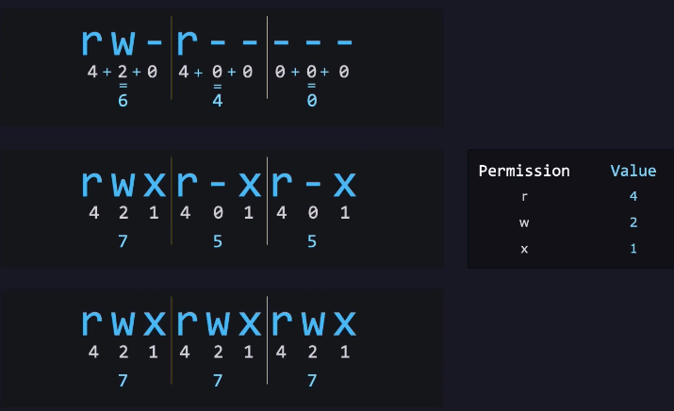

chmod 640 family_dog.txt

6 = rw- = User

4 = r-- = Group

0 = --- = Others

The default file permissions in Linux are 666, which gives read and write access to everyone:

|  |  |
| --- | --- |
| **File type** | **Default permissions** |
| File | 666 (rw-rw-rw-) |
| Directory | 777 (rwxrwxrwx) |

The default mask for a non-root user is 002, which changes the file permissions to 664 (rw-rw-r--).

SUID SGID Sticky Bits

Monday, December 23, 2024

10:32 AM

SUID: It is special file permission for executable files. This enables other users to run the file with the effective permissions of the file owner. But Instead of normal x which represents executable permissions. We will see s(this indicates SUID) special permission for the user.

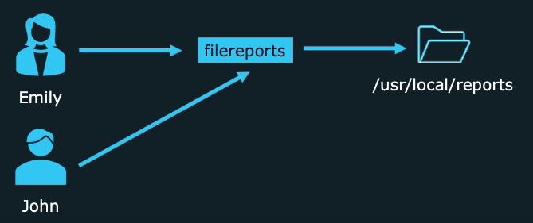

John can run the executable 'filereports' but John doesn't have access to the directory /usr/local/reports.

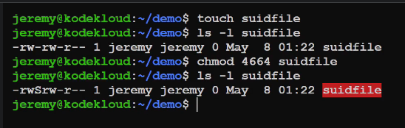

Here, starting '4' in '4664' permission means SUID is active.

In file permissions, you'll and 'S'. Example

rwS

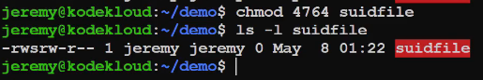

When you run -

chmod 4764 <filename>, It means 'x' and 's' both are set.

Here 's' is there and not 'S".

S: No one can execute the file (setuid/setgid exists, but no execute permission).

s: File is executable, and setuid/setgid will affect how it runs.

SGID = It is similar to SUID but applies to both executables and directories.

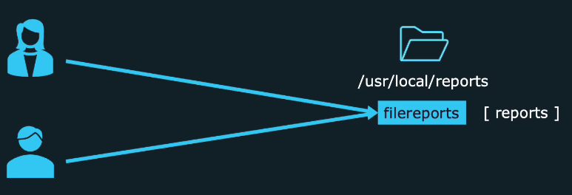

Here, John has both access to 'filereports' executables and the directory /usr/local/reports.

For GID, run the following command

example

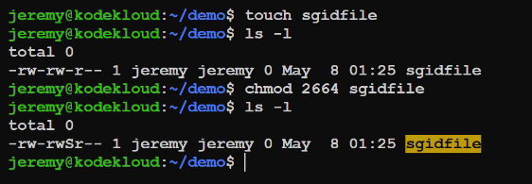

Here, you'll find 'S' in the group's file permissions.

If you run, chmod 2674. It will

Sticky Bits

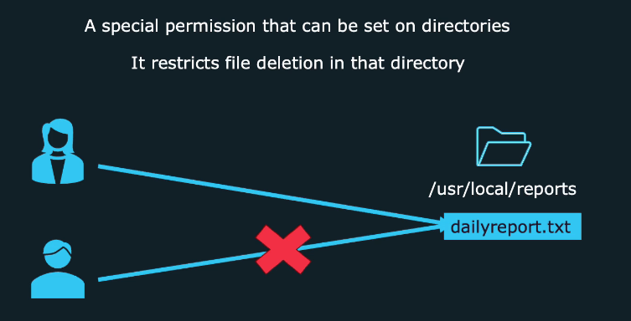

John can't delete the file. Only following can delete the file.

* + File Owner
  + Directory Owner
  + Super User (root)

example:

There is folder named 'stickydir'.

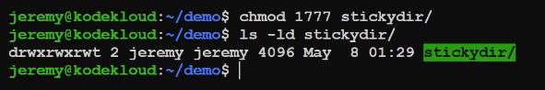

Sticky Bit with execute permission is represented by 't'.

* + **t (lowercase)**: Indicates that the **sticky bit** is set **and** the **execute permission** is also present for the others category.
  + **T (uppercase)**: Indicates that the **sticky bit** is set, but the **execute permission** is **not** present for the others category.

If we remove the permission by running command

chmod 1666 stickydir/

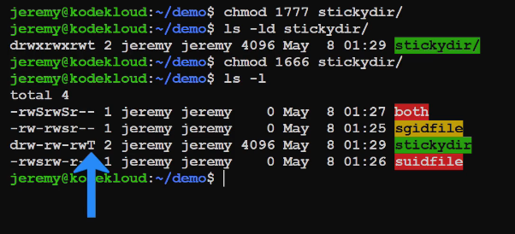

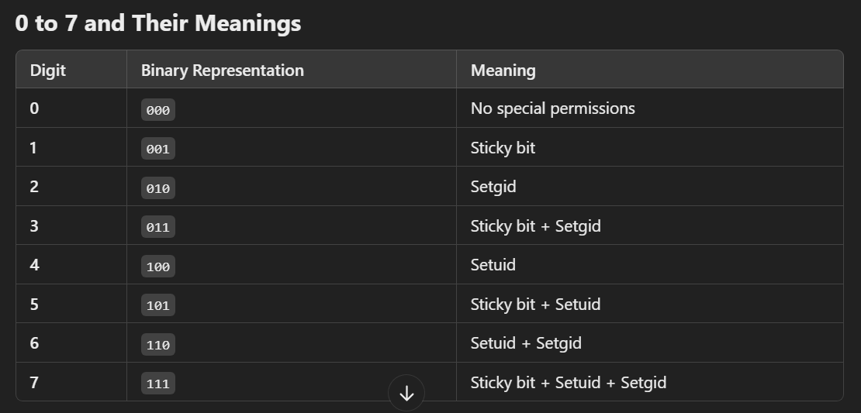

**Explanation of Each Special Permission**

* + **Sticky Bit (1)**:
    - **Files: Typically ignored but retained.**
    - **Directories: Ensures that only the owner of a file can delete or modify it within the directory, even if others have write permissions.**

* + **Setgid (2)**:
    - **Files: If executable, processes spawned from the file inherit the group ID of the file instead of the user's default group.**
    - **Directories: Files created inside inherit the group ownership of the directory, not the creator's default group.**

* + **Setuid (4)**:
    - **Files: If executable, processes spawned from the file inherit the user ID of the file owner instead of the user's default ID.**
    - **Directories: Not applicable; has no effect.**

Finding files with setuid permissions

Command:

find <directory> -perm /4000

This will search for any file with setuid flag, we put 0 after 4 bcoz other permissions does't matter to us.

Finding files with setuid and setgid permissions

Command:

find <directory> -perm /2000

This will search for any file with setgid flag, we put 0 after 2 bcoz other permissions does't matter to us.

Finding files with setuid or setgid or both permissions both

Command:

find <directory> -perm /6000

This will search for any file with setuid or setgid or both, we put 0 after 6 bcoz other permissions does't matter to us.

Search for Files

Monday, December 23, 2024

12:37 PM

Syntax of Find Command in Linux :

Here is the syntax for the find command in Linux:

find [path of directory where you want to search] [options] [expression]

Trick to remember:

find <go there> <find it>

Here,

path: Starting directory for the search.

Example: find /path/to/search

If there is no path, It'll search in the current directory.

options: Additional settings or conditions for the search.

Example: find /path/to/search -type f -name "*.txt"

expression: Criteria for filtering and locating files.

Example: find /path/to/search -type d -name "docs"

-size [+/-]n

Searches for files based on size. `+n` finds larger files, `-n` finds smaller files. ‘n‘ measures size in characters.

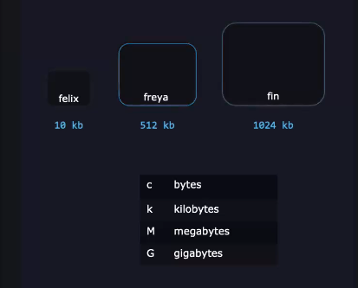

-name pattern

Searches for files with a specific name or pattern. Case sensitive.

-iname

Same as 'name' but case insensitive. e.g. find /usr/share -iname dogs.txt

-mtime n

Finds files based on modification time. `n` represents the number of days ago or 24 hours ago. mtime works with 24-hours period.

find -mtime 2 means file modifed at 2 days ago OR 48 hours ago.

-mmin n

Modified Minute

Examples

find -mmin 5

So, if current time is 12:05, mmin 5 means file modified at exactly 5 minutes ago which is 12:01 and NOT 12:00. mmin 5 will backtrack from current time.

mmin 5 = 12:05 -> 12:04 -> 12:03 -> 12:02 -> 12:01

find -mmin -5

So, if current time is 12:05, mmin -5 means file modified in last 5 minutes which is 12:05 to 12:01 and NOT 12:00. mmin -5 will also backtrack from current time.

mmin -5 = [12:05,12:04,12:03,12:02,12:01]

find -mmin +5

So, if current time is 12:05, mmin +5 means file modified in more than 5 minutes ago which is 12:00 and NOT 12:01. mmin +5 will not backtrack from current time but from 1 min earlier.

mmin +5 = 12:05(ignore) -> 12:04 -> 12:03 -> 12:02 -> 12:01 -> 12:00 -> 11:59 -> 11:58 …..

Examples

find -name "f*"

Search for filename starting with "f" after "f" , there can be 0 to n characters.

Change Time

This command refers to files or directories whose metadata changes. For example, when a file permission is changed.

find -cmin -5

This command is used to list the files whose metadata changed in last 5 mins.

We can combine multiple parameters in a single expression

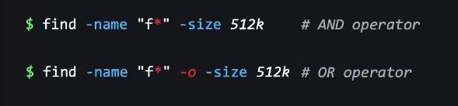

1. find a file which starts with 'f' AND has exactly 512 kb size.
2. find a file which starts with 'f' OR has exactly 512 kb size.

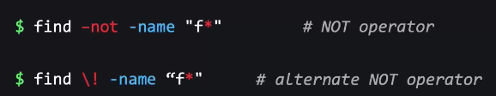

find a file which do NOT starts with 'f'

'\' or back slash is an escaping character which tells BASH that '!' is here a regular character.

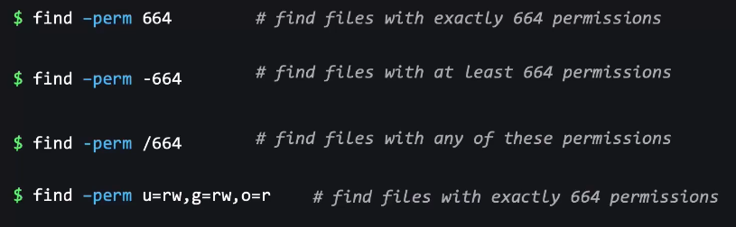

1. Files if they have read permission for user will also get listed as one condition matches.

KK Lab 3

Friday, February 14, 2025

6:11 PM

Find files/directories under the /var/log/ directory that the group can write to, but others cannot read or write to it.

find /var/log/ -perm -g=w ! -perm /o=rw

Find our secret file under /home/bob. You can either look for a file that is exactly 213 kilobytes or a file that has permission 402 in octal.

find /home/bob -size 213k -o -perm 402

Add the permissions for setuid, setgid, and sticky bit on the /home/bob/datadir directory.

chmod u+s,g+s,o+t /home/bob/datadir

Find all directories named pets in the /var/directory

sudo find /var/ -type d -name pets

Always use type command.

Find all the files which have been modified in the last 2 hours in /usr directory.

sudo find /usr -type f -mmin -120

Find all files between 5mb and 10mb in the /usr directory and save the output (along with parent path) in the/home/bob/size.txt file.

sudo find /usr -type f -size +5M -size -10M > /home/bob/size.txt

Create a directory named LFCS under bob's home directory and update its user owner permissions to only x (execute), and group and others should not have any permissions.

sudo mkdir /home/bob/LFCS

sudo chmod 0100 /home/bob/LFCS

Compare and Manipulate file content

Monday, December 23, 2024

11:52 PM

tac command in Linux is used to concatenate and print files in reverse.

The most basic use of ‘cat’ is to display the contents of a file on the terminal.

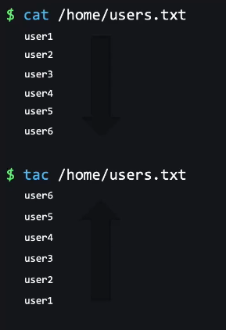

tail

The tail command, as the name implies, prints the last N number of data of the given input. By default, it prints the last 10 lines of the specified files.

head

The head command, as the name implies, print the top N number of data of the given input. By default, it prints the first 10 lines of the specified files. First one is the empty line.

sed

The SED (Stream Editor) command in Unix/Linux is a powerful utility used to process and manipulate text in files.

**Replacing or substituting string:**

Sed command is mostly used to replace the text in a file. The below simple sed command replaces the word “unix” with “linux” in the file.

$sed 's/unix/linux/' geekfile.txt

s means substitute.

2. Replacing the nth occurrence of a pattern in a line

Use the ‘/1’, ‘/2’ etc. flags to replace the first, second occurrence of a pattern in a line. The below command replaces the second occurrence of the word “unix” with “linux” in a line.

$sed 's/unix/linux/2' geekfile.txt

3. Replacing all the occurrence of the pattern in a line

The substitute flag /g (global replacement) specifies the sed command to replace all the occurrences of the string in the line.

$sed 's/unix/linux/g' geekfile.txt



-i        Edit the file in place without printing to the console for preview(overwrite the file).

cut Command

The cut command is used to extract sections from each line of input data. It can extract based on character, byte, or field (column) positions.

To extract the first column (names):

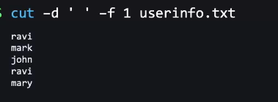

Here delimeter is space ( ' ')

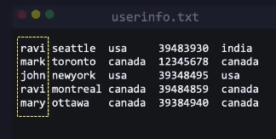

-f 1 means to extract the first field.

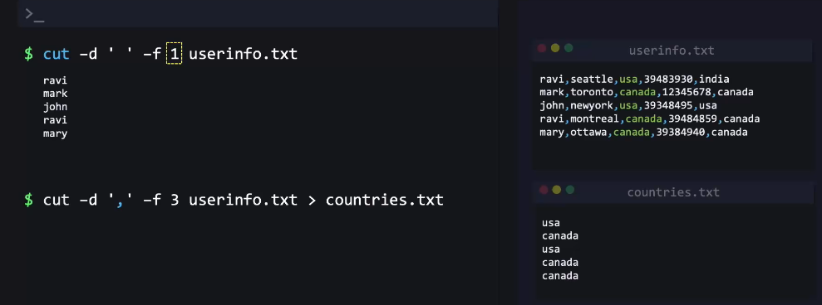

uniq

The Linux uniq command is used to remove all repeated lines in a file. This command is used when a line is repeated multiple times and replaces these multiple lines with one line. This command is designed to work on sorted files.

The repeated lines must be one after another, so first we sort them using 'sort' command and then pass the output to 'uniq' command.

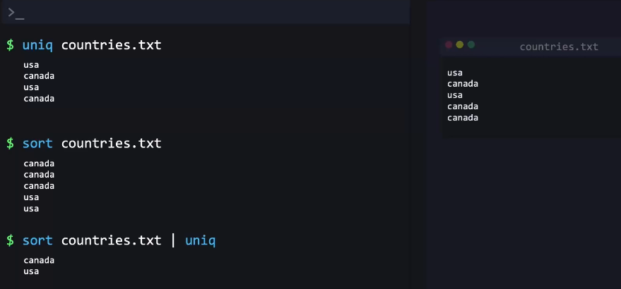

diff

diff stands for difference. Its primary purpose is to compare the contents of two files and display the differences between them.

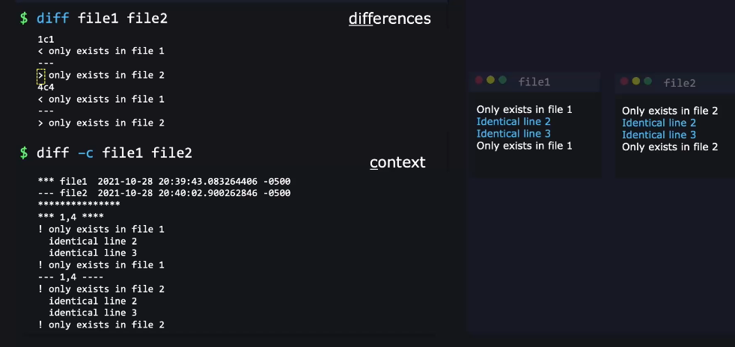

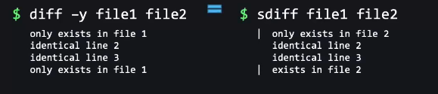

Pagers and Vim

Tuesday, December 24, 2024

12:21 AM

less

‘less’ allows you to view text files page by page without loading the entire file into memory.

'/' is used to search for a term. It is a case sensitive. Press 'n' for next character and 'N or Shift + n' to go to previous character.

-i = It is used to make it case insensitive.

more

Navigating Through Text Files Using the ‘more’ Command

While viewing text files with ‘more’, you can use the following controls for navigation:

Enter key: Scrolls down one line at a time.

Space bar: Moves to the next page or screen.

‘b’ key: Goes back one page.

‘q’ key: Quits the more command and exits the view.

Vim

vi improved

wq - write and quit

h = to move the cursor to left

j = to move the cursor down

k = to move the cursor up

l = to move the cursor right

/ - Used to search a term. Case sensitive.

To search for case insensitive term, put a '\c' after the term. e.g.

/success\c

:3 - To go to line 3

Grep

Tuesday, December 24, 2024

12:50 AM

grep [options] pattern [files]

1. Case insensitive search

The -i option enables to search for a string case insensitively in the given file. It matches the words like “UNIX”, “Unix”, “unix”.

grep -i "UNix" geekfile.txt

Displaying the Count of Number of Matches Using grep

We can find the number of lines that matches the given string/pattern

grep -c "unix" geekfile.txt

-R prints the searched pattern in the given directory recursively in all the files.

Syntax:

grep -r [Search] [directory]

To ignore case, user -i

grep -ir [Search] [directory]

use '--color' options for badhiya output

If you want to match the exact word.

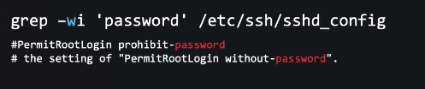

-w Match whole word

-o = Print only the matched parts of a matching line, with each such part on a separate output line.

Regular Expressions

Tuesday, December 24, 2024

1:08 AM

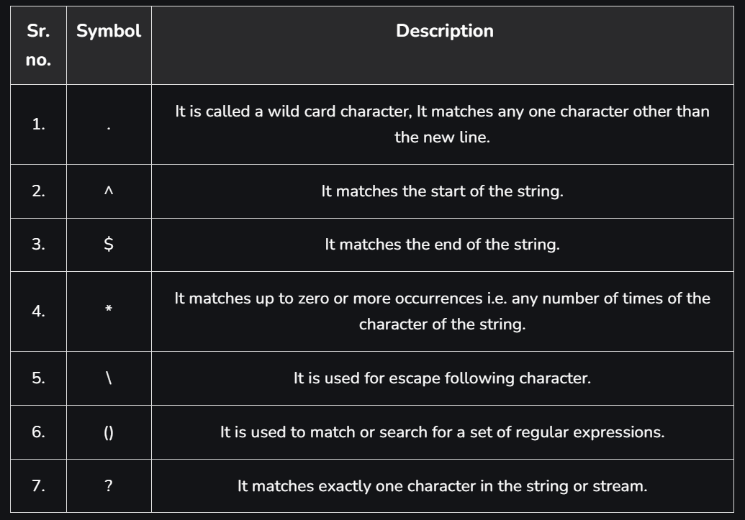

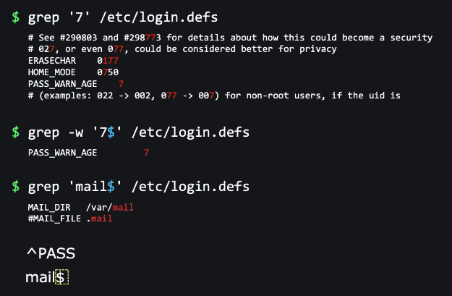

$ is put at the end as it is used to match the end of the string.

^ (caret) is used at the beginning as it is used to match the starting of the string.

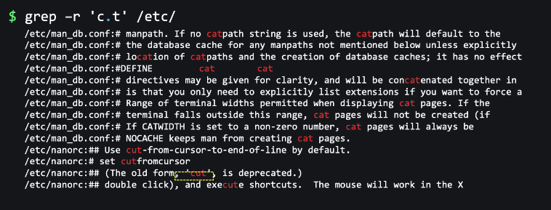

c.t = It will match with all the words with having a single character between 'c' and 't'.

c..t = It will match with all the words with having two character between 'c' and 't'.

'.' (dot) has special meaning in RegEx. What if you want to search '.' ?

For this, we use escape character which is a back slash(\). e.g.

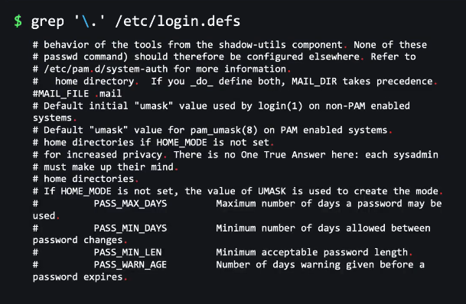

let* - It can match let, lett, lettt etc.

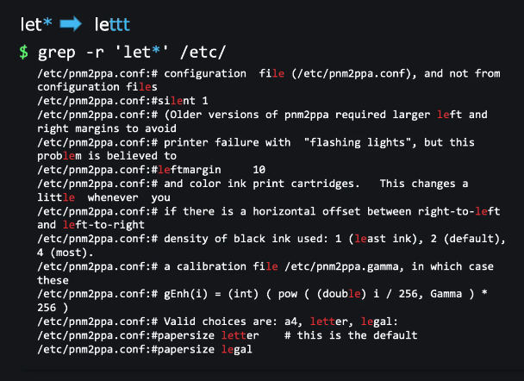

To search a file that begins with '/' and can have many '/'

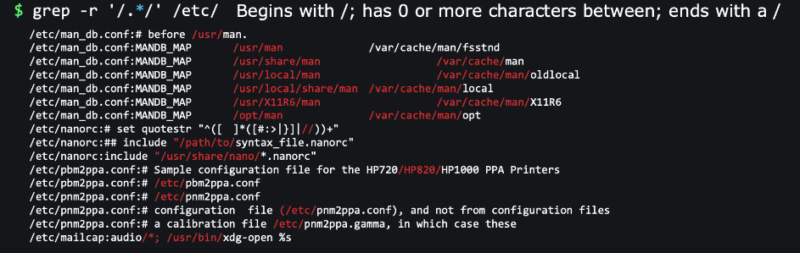

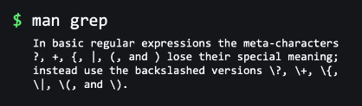

Extended Regular Expression

Friday, December 27, 2024

12:35 AM

This comes into play when you don’t want to confuse which character requires an escape character and which doesn't.

In order to allow a user to express the regular expression in more customized way, grep assigns special meanings to few characters. These characters are known as Meta characters. Initially, grep assigned the characters ^ $ . [ ] and * as Meta characters. Later few more characters were added in this list. These were ( ) { } ? + and |.

Basic Regular Expression( BRE) : - An expression which uses the default Meta characters.

Extended Regular Expression( ERE) : - An expression which uses the later added Meta characters. Extended Regular Expressions (EREs) are a superset of Basic Regular Expressions (BREs) in the context of text processing tools like grep, sed, and awk.

BRE vs ERE

Here's a breakdown of some key differences:

Metacharacters:

BRE: Requires backslash escaping for most metacharacters (\+, \?, \{, \|, ( )).

ERE: Most metacharacters are interpreted literally without needing a backslash. For example, + matches one or more occurrences of the preceding character directly.

Character Classes:

BRE: [] defines a character class. For example, [a-z] matches any lowercase letter.

ERE: [] also defines character classes, but with additional features like:

^ inside the brackets negates the class (e.g., [^a-z] matches any character not a lowercase letter).

- indicates a range of characters (e.g., [a-zA-Z] matches any letter).

Anchors:

BRE: ^ matches the beginning of a line (requires escaping as \^). $ matches the end of a line (requires escaping as \$).

ERE: ^ and $ directly match the beginning and end of a line, respectively.

Example:

Let's say you want to find lines containing the word "foo" followed by zero or more occurrences of the letter "b".

BRE: grep -e 'foo\b*'

ERE: grep -E 'foob*'

grep -E is similar to egrep.

Find term ending with 0.

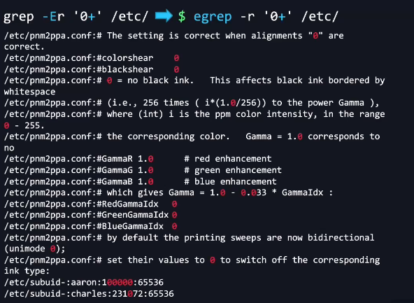

Find min 3 zeroes

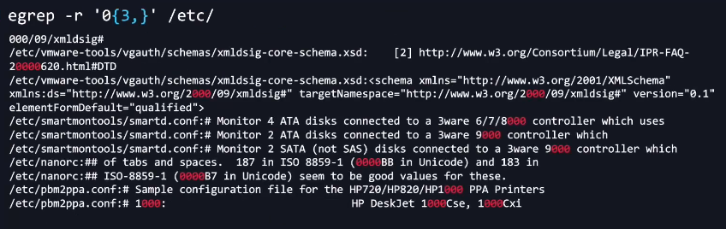

{3,} = Min 3, Max infinite.

Find 1 with minimum no 0s and maximum 3 zeroes next to it.

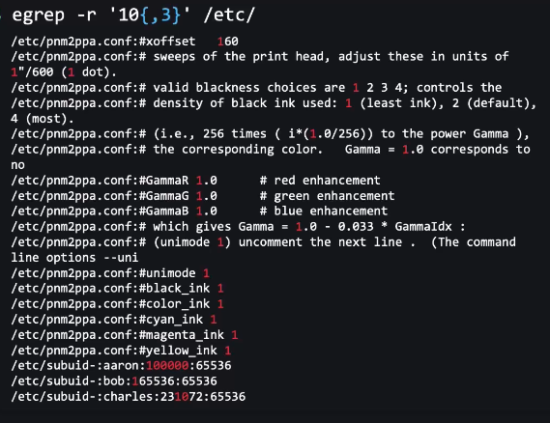

Find terms with exact 3 zeroes.

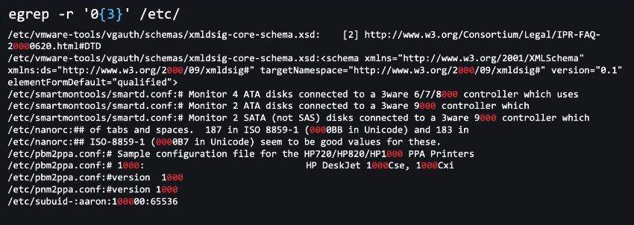

Character before '?' should be 0 or 1 time basically to make that character an optional.

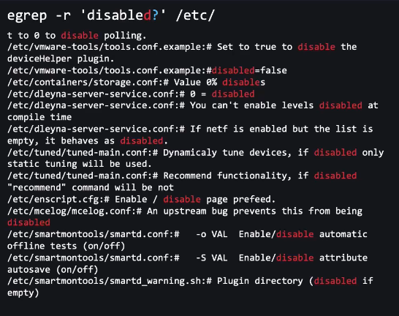

Words found - disable, disabled, disables

using -w flag with above command e.g. egrep -wr then it will only search for word disable or disabled.

OR operator

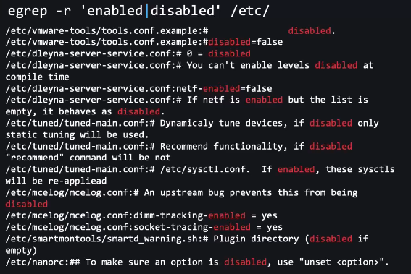

Search for word - cat OR cut

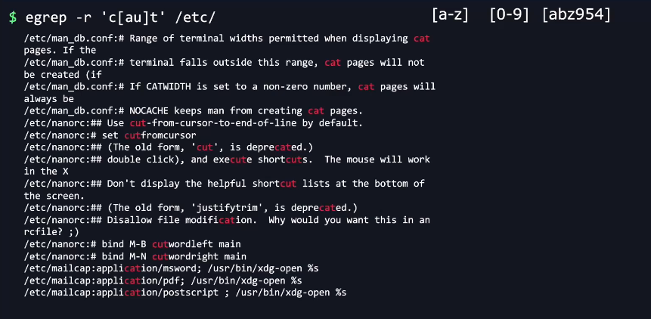

[a-z] = Search for a character from a to z.

KK Labs - 4

Saturday, February 1, 2025

8:55 PM

How would you extract/print the b and the y?

a;b;c;d

x;y;z

cut -d ';' -f 2 testfile

Output:

b

y

Change all values enabled to disabled in the /home/bob/values.conf config file.

sed 's/enabled/disabled/g' /home/bob/values.conf

Change all values disabled to enabled in the /home/bob/values.conf config file, ignoring the case sensitivity.

sed -i 's/disabled/enabled/gi' /home/bob/values.conf

Input Output Direction

Friday, December 27, 2024

1:20 AM

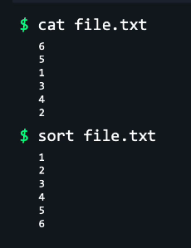

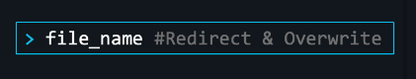



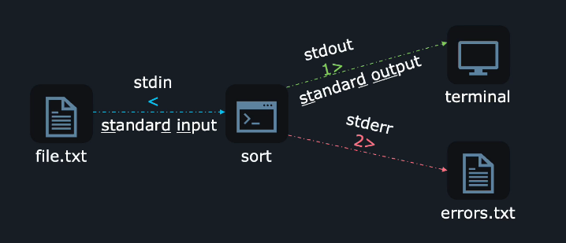

2> - Use this to redirect to errors or warnings.

1> - Use this to redirect the successful events.

Below two commands are similar.

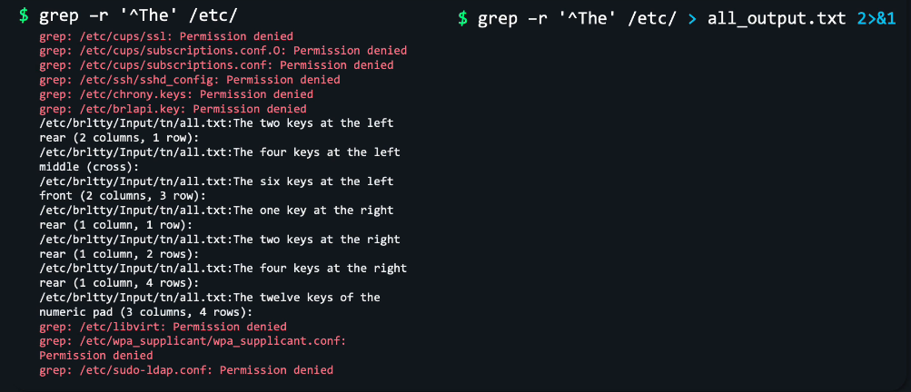

2>&1: This part redirects the standard error output (which might contain error messages from grep, such as permission denied for some files) to the standard output.

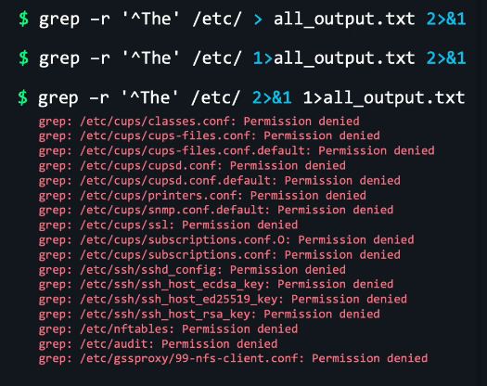

grep -r '^The' /etc/ 2>&1 1>all_output.txt

It means first standard error goes to standard out and then this standard out redirects to all_outut.txt

Here Document ( heredoc)

A heredoc is a block of text that is treated as input to a command. It starts with << followed by a delimiter (which can be any word or symbol). The text following the delimiter is treated as input until the delimiter appears again on a line by itself.

cat <<EOF

This is a multiline string.

It can span multiple lines.

EOF

Herestring

A herestring is a simpler version of heredoc. It's a single-line string that is passed to a command using the <<< operator.

grep "world" <<< "Hello, world!"

Heredoc uses << and a delimiter, while herestring uses <<<.

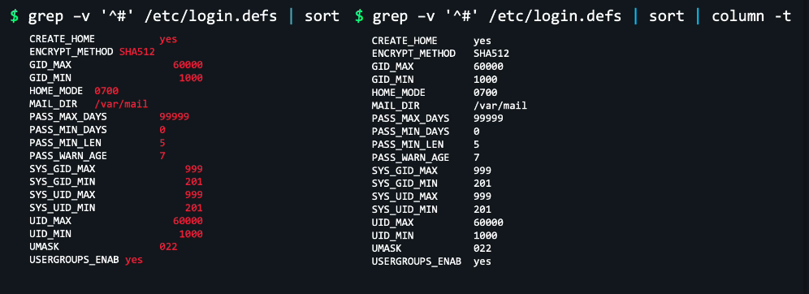

KK Lab 5

Friday, February 14, 2025

11:58 PM

Redirection

Backup, Compress, Archive - Optional for LFCS

SSL - TLS

Thursday, February 13, 2025

12:19 AM

Authentication verifies a user's identity, while authorization gives the user permission to access a resource.

What we call SSL in the past is now the TLS. SSL is upgraded to TLS.

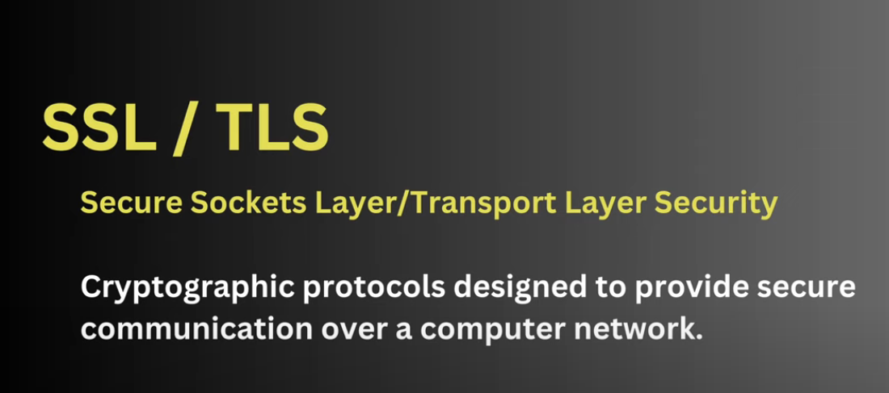

For eg. To access a banking website, we enter the username and password. Hacker can steal these credentials so we need to secure this. SSL/TLS are used to secure these credentials.

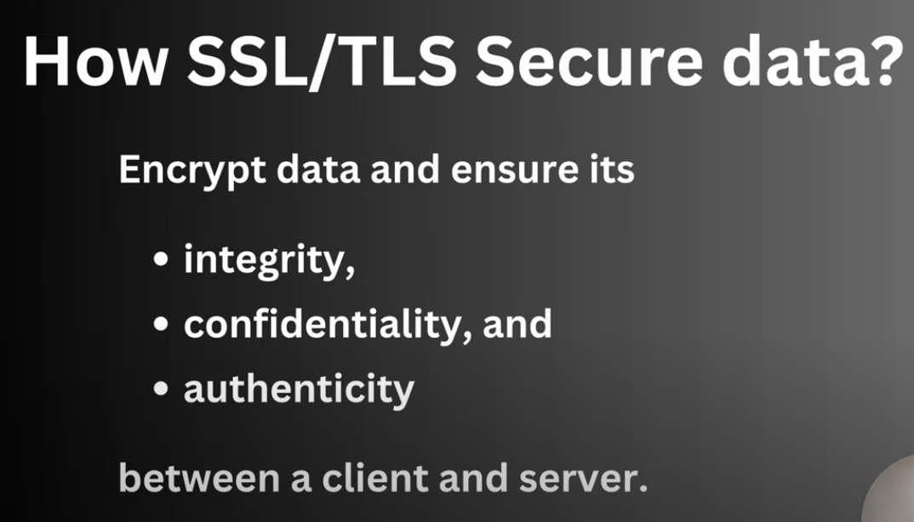

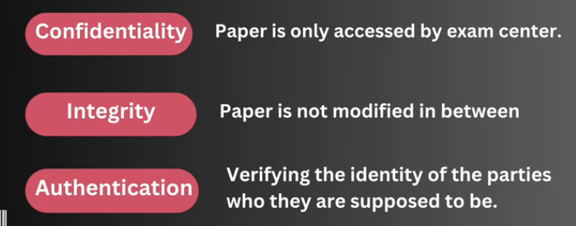

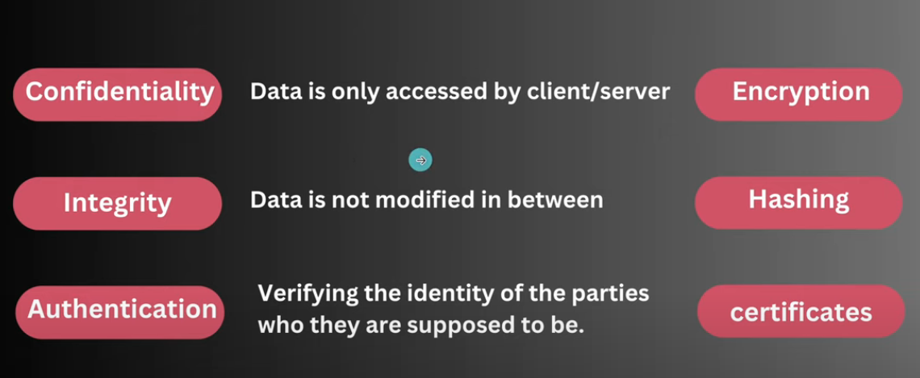

For confidentiality, Encryption is used.

For Integrity, Hashing is used.

For Authentication, Certificate is used.

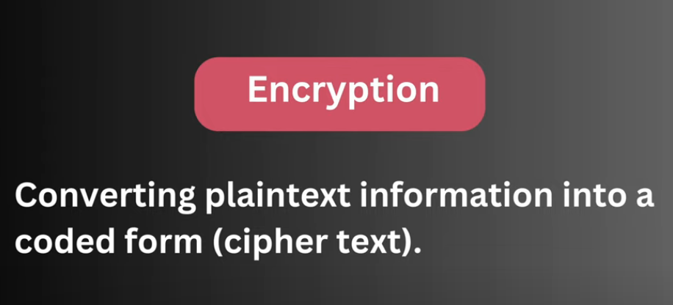

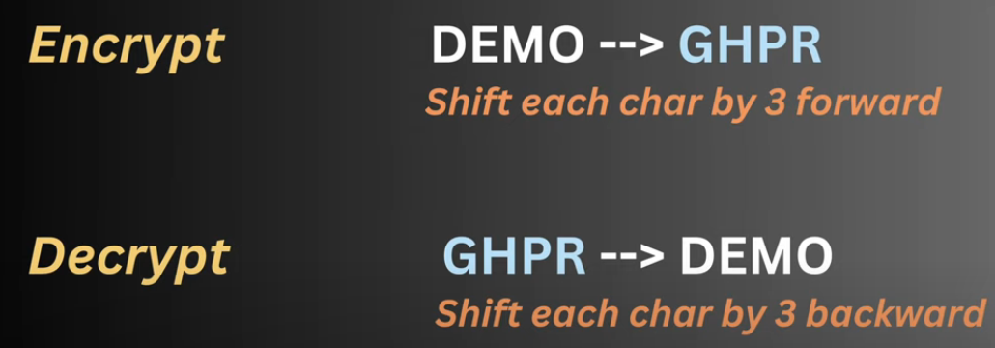

Types of encryption

Symmetric

Asymmetric

Symmetric - Same key is used for encryption and decryption. e.g. key=3

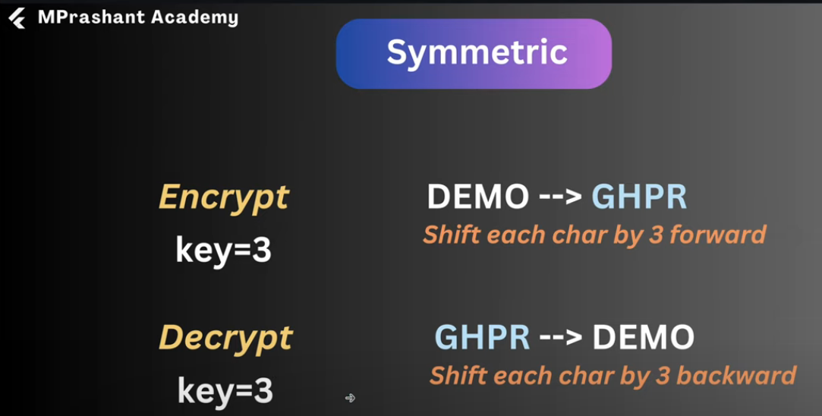

Asymmetric - Different keys are used for encryption and decryption.

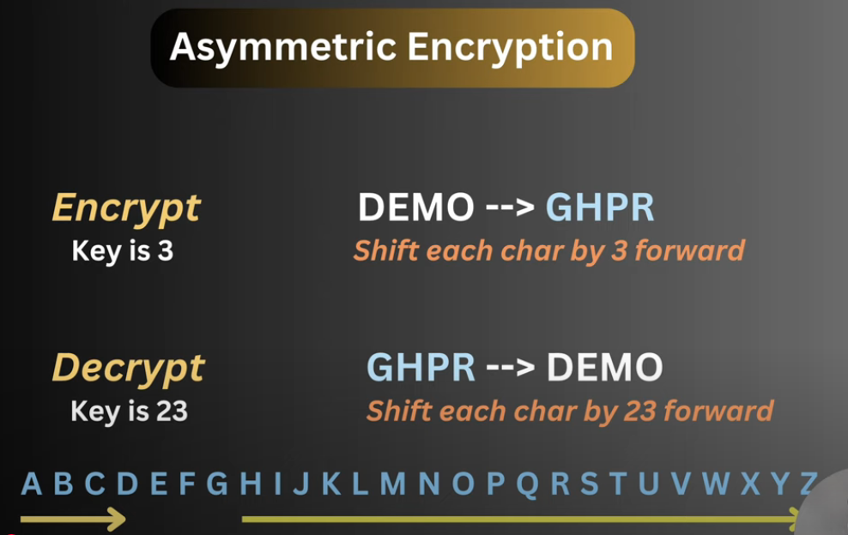

Asymmetric is more secure.

Public and Private key

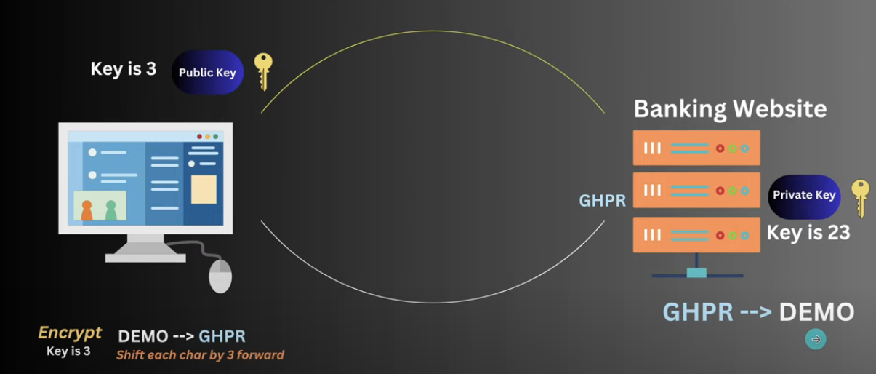

SSL/TLS Steps

1️⃣ User initiates a connection (Handshake starts)

The user enters <https://bank.com> in the browser.

The browser requests a secure connection (HTTPS).

2️⃣ Bank server sends its SSL/TLS certificate

The bank server responds with its SSL/TLS certificate, which contains:

The bank’s public key

The certificate authority (CA) signature (to verify authenticity).

3️⃣ User verifies the bank's certificate

The browser checks if the certificate is valid and trusted by a CA.

If the certificate is invalid, the user gets a security warning.

4️⃣ Key Exchange (Session Key Generation)

The user's browser creates a random session key (used for encryption).

The browser encrypts this session key using the bank's public key.

The encrypted session key is sent to the bank server.

5️⃣ Bank decrypts the session key(Handshake completes)

The bank server uses its private key to decrypt the session key.

Now, both the user and bank have the same session key.

6️⃣ Secure Communication Begins (Using Session Key)

All further communication (including login credentials) is encrypted using symmetric encryption with the session key.

This is faster than asymmetric encryption.

7️⃣ User logs in securely

The browser encrypts login credentials using the session key.

The bank decrypts them using the same session key.

What is the Handshake in SSL/TLS?

The TLS handshake is the process in which the user's browser and the bank server establish a secure encrypted connection before exchanging any sensitive data.

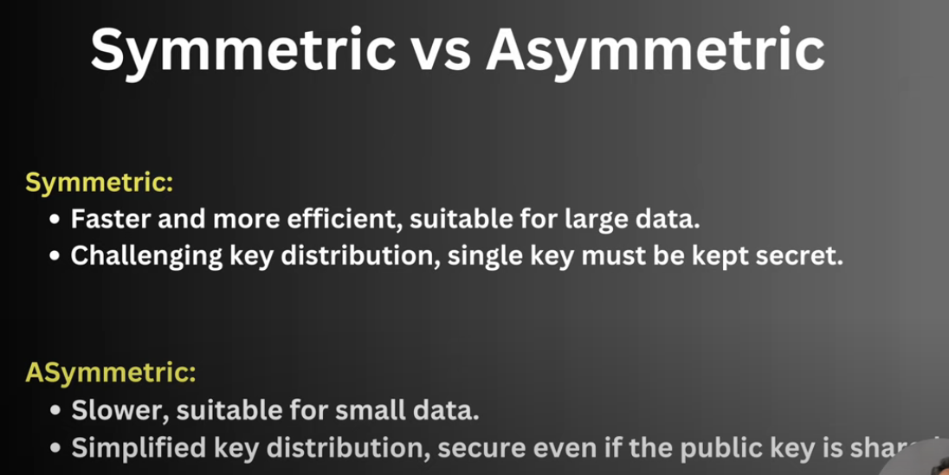

There's also third type of Encryption

Hybrid Encryption - it utilizes the strength of Symmetric and Asymmetric encryption both.

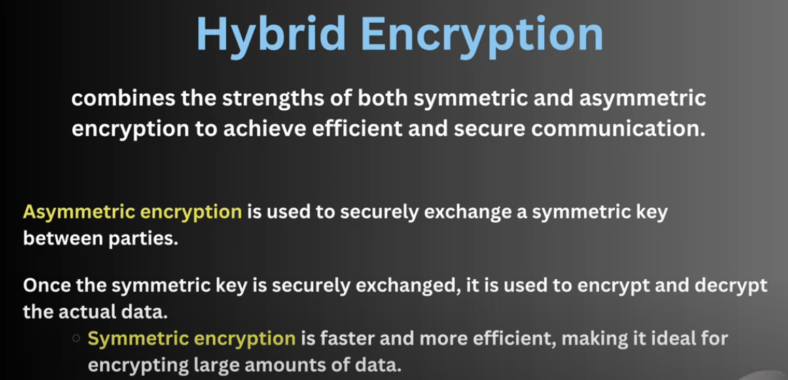

📌 Step-by-Step Hybrid Encryption Process (Bank Website Example)

1️⃣ User accesses the bank website (Handshake begins)

2️⃣ Bank server sends its SSL/TLS certificate containing the public key (Asymmetric Encryption)

3️⃣ User’s browser verifies the certificate using a trusted Certificate Authority (CA)

4️⃣ Browser generates a random symmetric key (Session Key)

5️⃣ Browser encrypts the session key using the bank’s public key (Asymmetric Encryption)

6️⃣ Encrypted session key is sent to the bank server

7️⃣ Bank server decrypts the session key using its private key (Handshake completes)

8️⃣ Now both the user & bank have the same session key (Symmetric Encryption starts)

9️⃣ All further communication (login credentials, transactions) is encrypted using the session key

Hashing

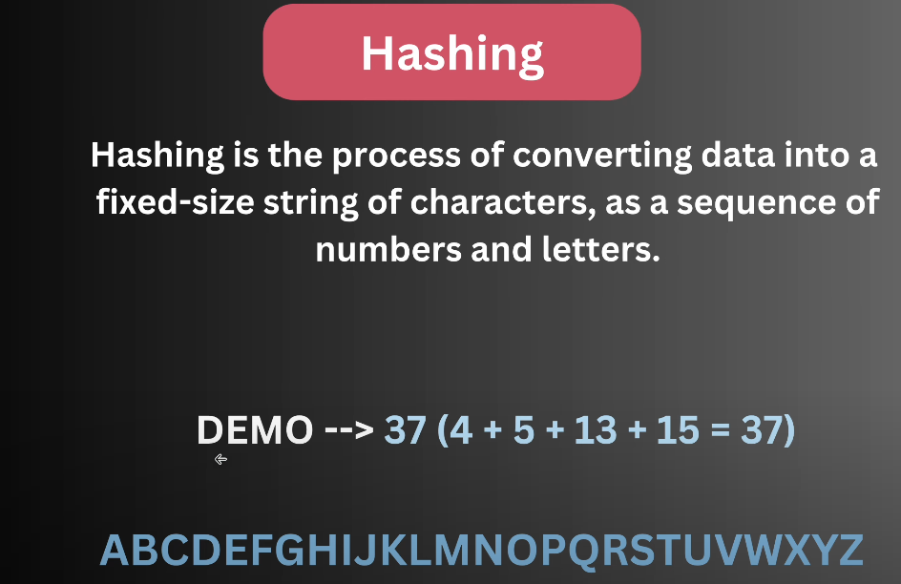

D is the 4th letter in A-Z.

The result we get i.e. 37 is called Digest or Checksum.

To convert a word 'DEMO' and obtain a checksum using 'md5sum' algorithm we get

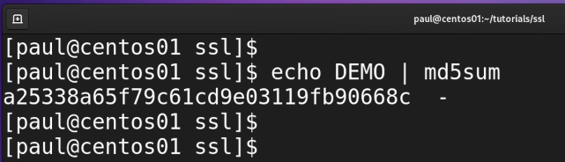

This 'a2….8c' is the checksum.

The length of checksum will be same for any word like 'DEMO', 'HELLO WORLD' etc.

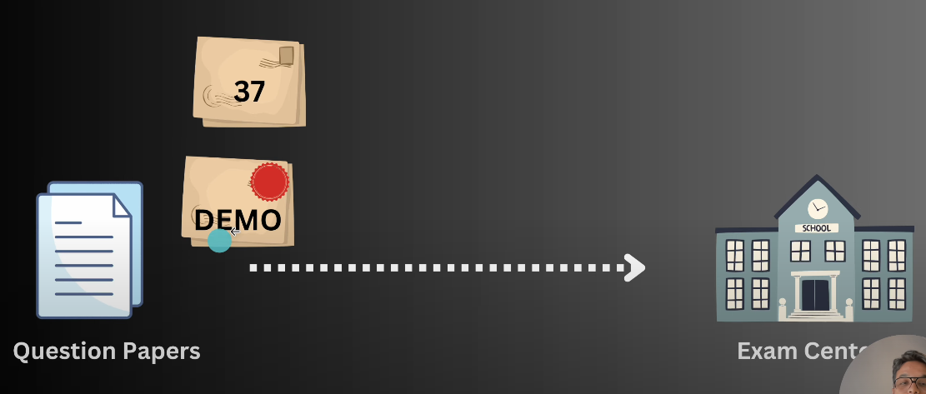

Question Paper (DEMO) and Checksum both will be sent to Exam Centre this time.

Now, if hacker changes the word 'DEMO' to 'MEMO', you will get different checksum which is not similar to the checksum of word 'DEMO' so this means someone has changes the word 'DEMO' and that's how Hashing helps in maintaining the Integrity.

Now, suppose the Hacker is more smart and he changed the checksum value and word both

DEMO = 4 + 5 + 13 + 15 = 37

MEMO = 13 + 5 + 13 + 15 = 46

Now, we have checksum as 46, if we calculate the hashing of MEMO, we will get 46 and then we assume that 'MEMO' was the right word.

To prevent this, we use MAC

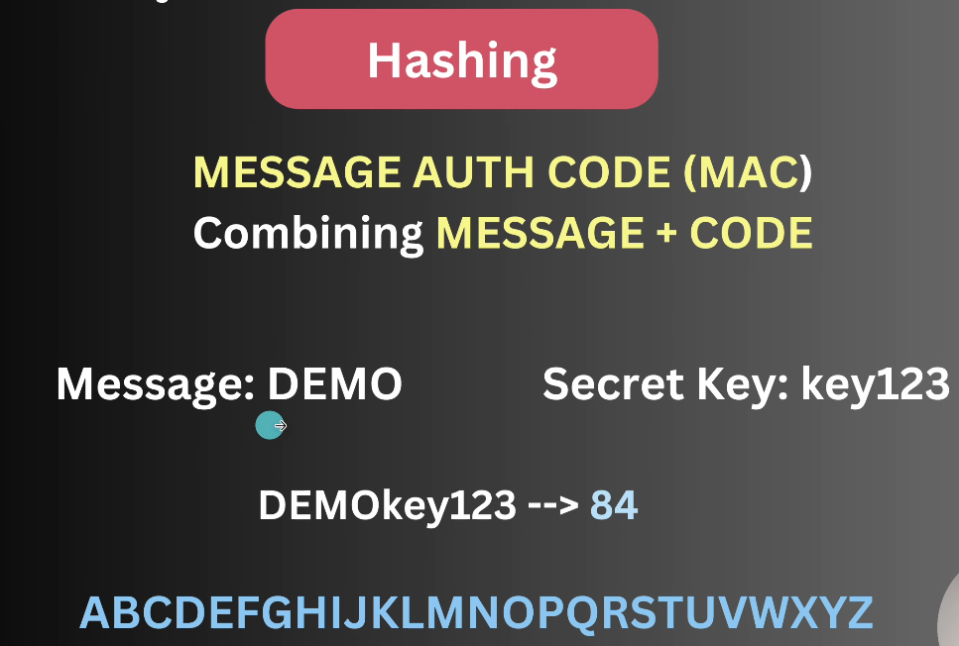

Now again we will send this Question Paper (DEMO and not DEMOkey123) to the Exam Centre and then Exam centre will again calculate the Hashing as they will already have a Secret Key.

Hashing Algo(Most Common)

MD5 - Message Digest Algo 5(128 bits)

SHA - (Secure Hash Algorithm)

sha-1

sha-2/3 224 256 384 512 - This 224, 256 etc are bits of checksum generated.

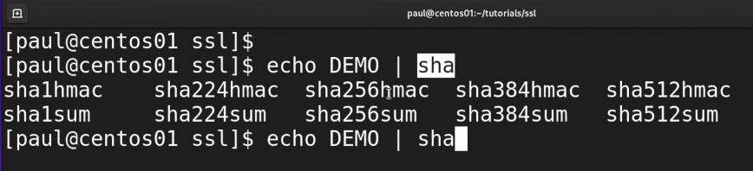

sha256hmac

Hash Based Message Authentication Code



Authentication

Certificate Authority (CA)

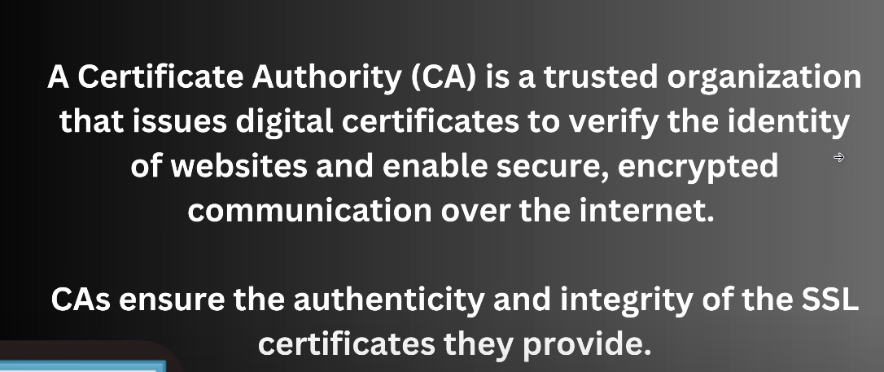

Step-by-Step Hashing & SSL/TLS Certificate Process

1️⃣ Banking Website Requests a Certificate from the CA

The banking website generates a key pair (a public key and a private key).

The website sends a Certificate Signing Request (CSR) to a Certificate Authority (CA).

The CSR contains:

Website’s public key

Website’s domain name

Other details (organization, location, etc.)

2️⃣ CA Issues a Digital Certificate

The CA verifies the banking website’s identity (based on domain ownership or business verification).

The CA signs the certificate using its own private key.

The certificate contains:

The bank's public key

The CA's digital signature (ensuring authenticity)

The hashing algorithm (e.g., SHA-256) used for integrity

Other metadata (validity dates, issuer info, etc.)

3️⃣ Banking Website Sends Certificate to the Browser

When a user visits the banking website, the server sends the SSL certificate to the browser.

4️⃣ Browser Verifies the Certificate

The browser checks if the certificate is valid using the CA’s public key (pre-installed in browsers).

The browser:

Extracts the fingerprint (a hash of the certificate).

Checks if it matches the one in the CA's record.

Ensures the certificate is not expired or revoked.

5️⃣ Browser Extracts the Bank’s Public Key

Once the certificate is verified, the browser extracts the bank’s public key from it.

This public key is used for encrypting data (e.g., login credentials).

6️⃣ Secure Communication Begins

The browser and the banking website establish a secure connection using asymmetric encryption initially.

After the handshake, they switch to symmetric encryption for faster communication.

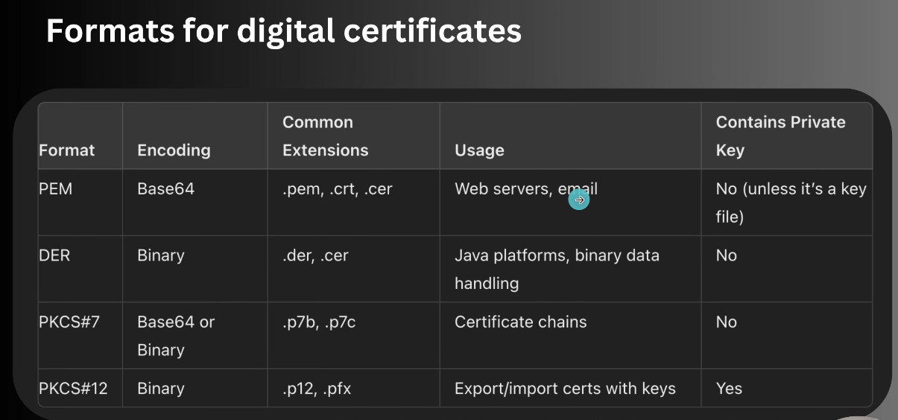

Working with SSL Certificates

Saturday, February 15, 2025

3:30 PM

openssl - it is a tool used to create X.509 certificates, create and manage public/private keys.

Search for manual for each subcommands like - man openssl-req

You can also search for examples in manual pages - "/Example".

openssl req

This command deals with the certificate signing requests.

What is a CSR (Certificate Signing Request)?

A Certificate Signing Request (CSR) is a formal request sent by a website or server to a Certificate Authority (CA) to obtain an SSL/TLS certificate.

It contains essential details about the website and its public key, which the CA verifies before issuing a signed certificate.

1️⃣ Generate a Key Pair (Public & Private Keys)

The server administrator (e.g., the banking website) first generates a key pair:

Private Key → Stored securely on the server

Public Key → Included in the CSR

2️⃣ Create the CSR File

Using the private key, a CSR file is created.

The CSR contains:

Common Name (CN) → The domain name (e.g., [www.bank.com](http://www.bank.com))

Organization Name (O) → The company name

Organizational Unit (OU) → Department (e.g., "IT Security")

City/State/Country → Organization’s location

Public Key → Used for encryption

Hashing Algorithm → (e.g., SHA-256)

Example command to generate a CSR:

openssl req -new -key private.key -out request.csr

openssl req -newkey rsa:2048 -keyout key.pem -out req.pem

key.pem is the private key

req.pem - CSR generated.

The user is prompted to enter details like domain name and company information.

3️⃣ Submit CSR to Certificate Authority (CA)

The CSR file (request.csr) is sent to a trusted CA (e.g., Digicert, Let's Encrypt, GoDaddy).

The CA verifies:

Domain Ownership (via email/DNS validation)

Company Legitimacy (for Extended Validation certificates)

If valid, the CA signs the CSR using its private key and issues an SSL/TLS certificate.

4️⃣ Receive & Install the Signed Certificate

The CA returns a signed SSL/TLS certificate to the banking website.

The server installs the certificate along with the CA’s root/intermediate certificates.

The certificate is now trusted by browsers, enabling secure HTTPS connections.

Command to geneate the self signed certificate

Difference between a self-signed certificate and a certificate issued by a Certificate Authority (CA)

Self-Signed Certificate

Generated locally by the organization without involving a CA.

Typically used for internal testing, development, or private networks.

openssl req -x509 -noenc -newkey rsa:2048 -days 365 -keyout mykey.key -out mycert.crt

CA-Signed Certificate (Trusted Certificate)

A Certificate Signing Request (CSR) is sent to a trusted Certificate Authority (CA).

The CA verifies the organization and signs the certificate using their private key.

The self-signed certificate has following structure

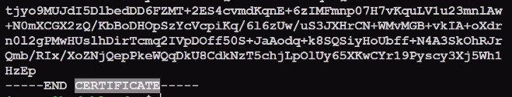

To get the information about the certificate genereated using x509

-text - It is used to print the certificate in the text form.

-in - Input file

openssl x509 -in mycertificate.crt -text

Revision

Friday, February 14, 2025

7:18 PM

Practice find commands - Lab 3

git

Saturday, February 15, 2025

4:08 PM

git config --global user.name "vaibhav"

git config --global user.email "vaibhav@email.com"

git init - To initialize . This will create a .git directory. This .git directory stores all the information related to the repositories.

branches, config, description etc.

To make local config settings inside a directory where git is initialized.

git config user.name "vaibhav"

git config user.email "vaibhav@email.com"

You can verify the above configuration

cat .git/config

Staging and Committing Changes

1. Make changes in working area
2. Add changes we want to track with Git to the staging area
3. Committing our changes

git status

Add file to staging area

git add file1 file2

Unstage a file

git reset file2

Add all the files with html format to Staging Area

git add "*.html"

Add all the files under a directory to staging area

git add products/

Add all the files under a directory with html format to staging area

git add "products/*.html"

Always use quotes when using "*" character.

Committing Changes

git commit -m "Added first two files"

To remove a file from the repository

git rm <file>

Now you have to run git commit to remove the file form the remote repo.

Git Branches and Remote Repo

Master is the default branch. It is usually the production one.

To add a branch

git branch <name>

To delete a branch

git branch --delete <name>

To see all the branches

git branch --list

To switch to a branch

git checkout <branch>

you can skip the git add step using this -

git commit -a -m "message"

git log

This will display what changes are done in the repo and by whom

git log --raw

To check what files were actually changed

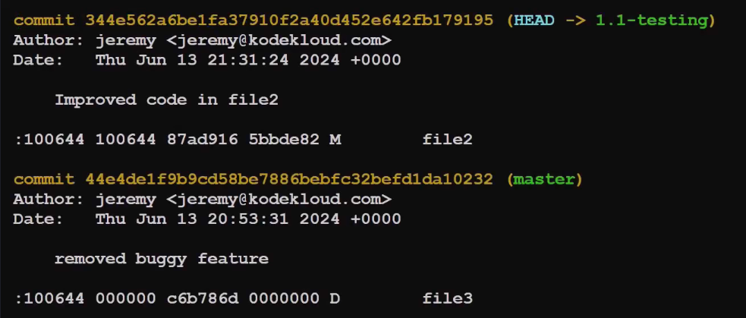

D - Delete File

M - Modified File

A - Added

commit hash - 44e4………232

This is used to uniquely identify each entry.

git show <first four characters of hash>

To merge a branch to Master branch

1. git checkout master
2. git merger <branch name to be merged>

To add a remote repository to your local repo

1. git remote -v
2. git remote add origin <url>

origin is the alias for our remote repo name.

1. git remote -v

Now you will get two options - push and fetch

1. Now configure the ssh keys to login to this repo

Run 'ssh-keygen' command for this.

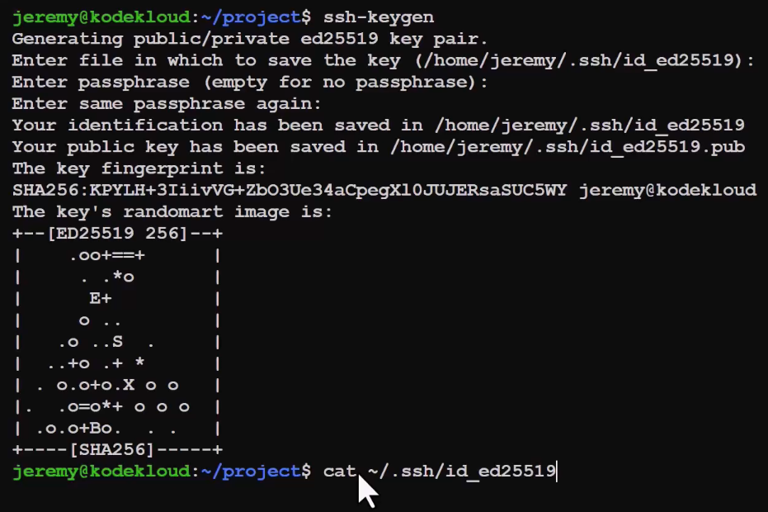

1. cat to this ~/.ssh/id_ed25519 and copy the code
2. Go to the Github UI > SSH and GPG Keys > New SSH key. Put a title and paste the key. Select the 'Key Type' as authentication key.

To push local commits to remote repo named 'origin' on Master Branch

git push origin master

To pull

git pull origin master

To clone a repo - This will have all the files including ".git"

git clone <url>